|  |  |
| --- | --- |
| **Project – External Document** |  |
| COMP6115  Object Oriented Analysis & Design |
| Even Semester Year 2020/2021 |

* **Project Title**

Just DU It!

* **Introduction**

In this project we created the Point of Sales application for Just Du It store. By using Java Programming language and MYSQL database. We also attach our source codes and SQL files with some dummy data included.

* **Report / Documentation**

1. Login

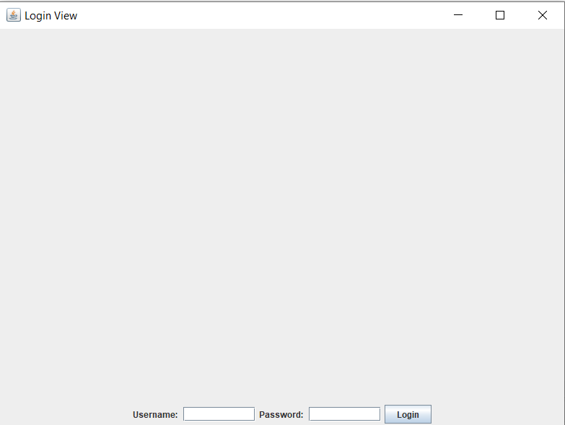

In this section, there is a username field and a password field to validate the users. Since you are new here, we gave you some lists of users that may be useful for you.

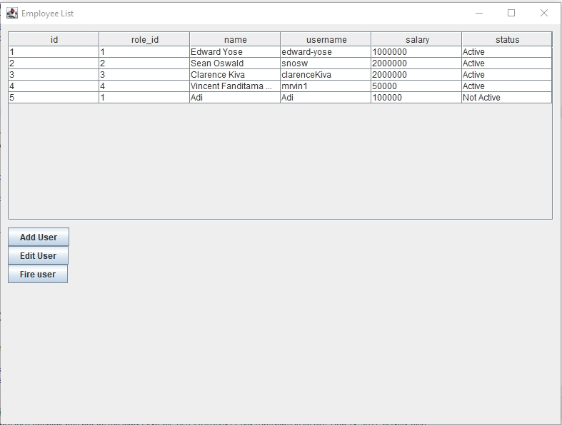

Login is achieved by a series of smaller functions. Since some roles utilize the same view with different components, some views accept a parameter which changes which components to display according to the user’s role.

The login functions create a new view and sets the new view’s frame visible. This is done to accommodate importing contentPanes without setting a Frame visible. Therefore, every main (size 800x600) view class outside of login can not have their frame set visible on their own.

**Please note** that upon opening the frame, your keyboard cursor automatically focuses on the username text field, and clicking enter on either field submits the login information. This improves user experience and maintains consistency with login screens everywhere else.

1. Transaction Management

After login to the cashier account, the user (cashier) can see the product list, before he/she can process the cart. The user can add to cart after pressing the add to cart button.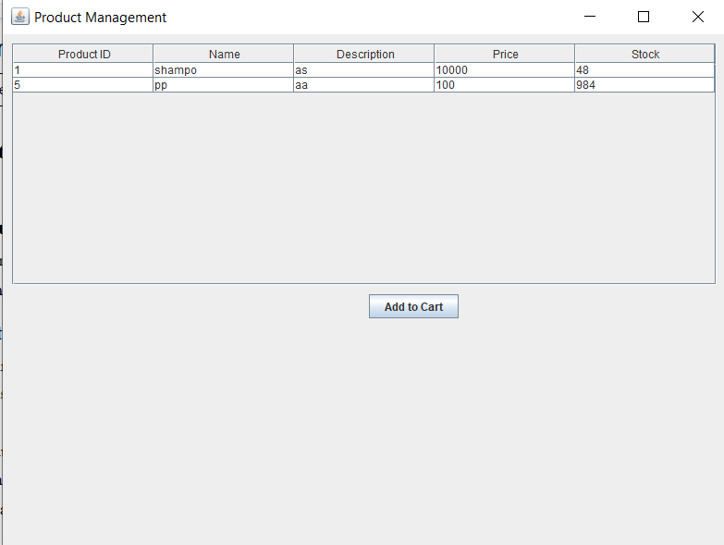

In this Transaction Management window, there is an updated cart table and the user can add the item to cart based on product id and quantity. And also the user can delete the item from the cart, just input the product id and press the remove item button.The total price will always be calculated when the user adds or removes the item from the cart. If the cashier already finished input the item to cart, he can check out the cart and the window will pop up like this:

and based on the case, we provide two available payment methods, either cash and credit card will record the transaction, to look at the history transaction, he/she can also click the “view history” button. Clicking a transaction in Transaction View opens a new frame/window with the transaction details, this will be discussed further in the Manager View section.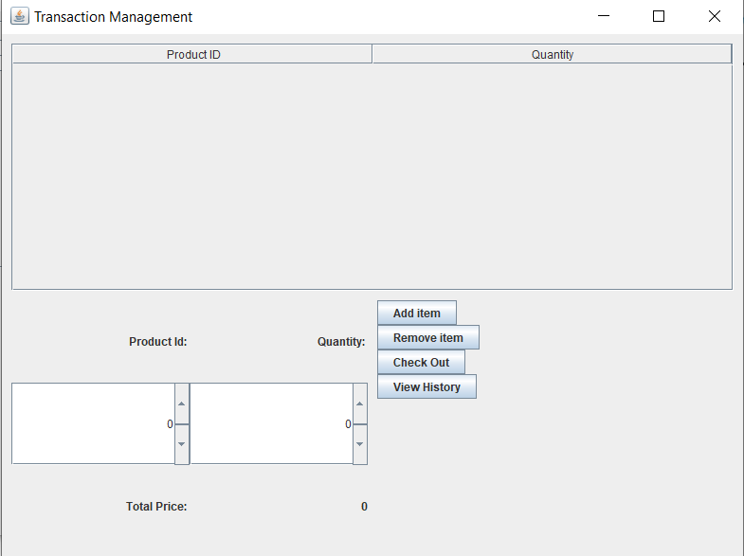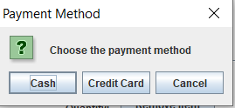

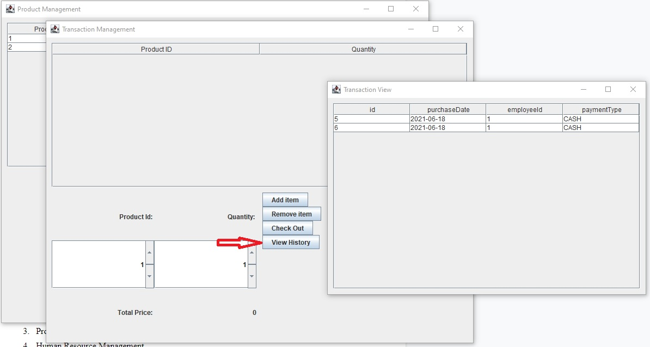

1. Product Management

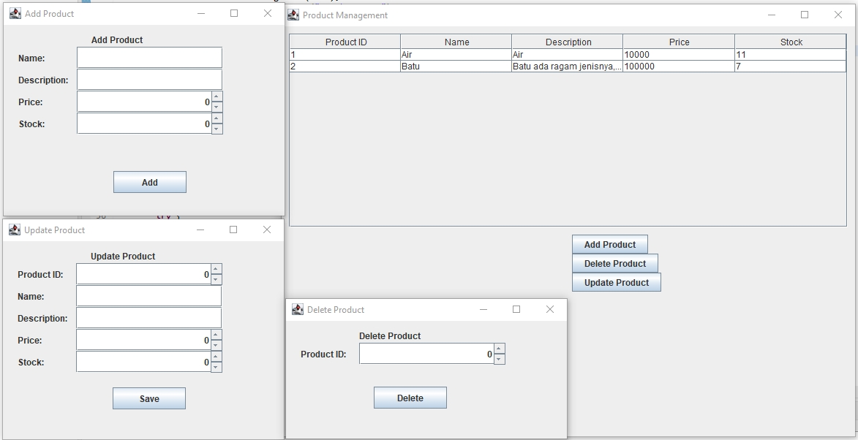

In this product management window, there is a main window that shows the list of products available and sold out. users can add, delete, or update the product. Users can add stock via edit product, add brand new product via add product, or delete product via delete product.

1. Human Resource Management

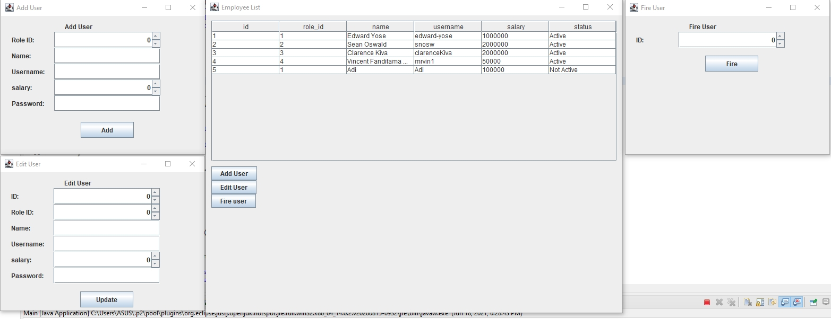

In this Human Resources Management window, we provide some employee lists, they can add, edit or fire users. Users also can change their role, salary, username, name, and even their employee status.

1. Manager

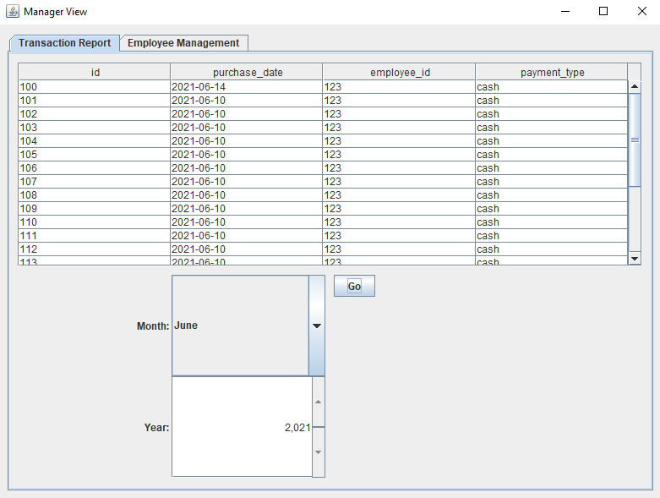

In the Manager View window, a tabbed pane is used to easily navigate between both of the manager’s jobs. The first tab at first displays every transaction ever recorded, which can then be filtered by month and year by using the month combobox as well as the year scroller.

The manager can then click on any transaction in the table in order to view its contents. Clicking on a table entry opens a new window containing the transaction id, transaction item id, and the quantity of each transaction item.

**Please note** that clicking different table entries does not just conveniently open a new frame/window containing a new table but instead refreshes the already existing window’s table. This is done to reduce resource usage and improve user experience. This is also true in Transaction Management’s Transaction View.

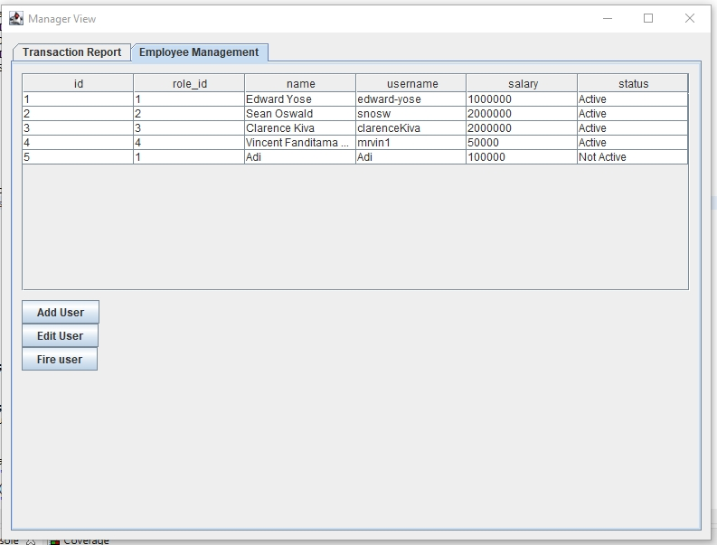

The second tab - Employee Management - is identical to the Human Resource Management’s window. This is achieved by importing the entire HRD contentPane into the second tab, which is the entire reasoning behind every component in every view being added into the contentPane instead of the frame directly.

* **Reference**
* Use mysql-connector-java-5.1.49.jar from teaching assistant
* **Group Member**
* 2301865823 – Clarence Aurelio
* 2301877470 – Edward Yose
* 2301856195 – Sean Oswald
* 2301885983 – Vincent Fanditama Wijaya